Analysis of Denoising Autoencoders
Vinuthna Ganta
The University of Texas at Dallas
Richardson, USA
vxg220101@utdallas.edu

Abstract—This project examines a denoising autoencoder of a neural network model, designed to reconstruct image data from the Fashion MNIST dataset. While general implementations for denoising autoencoders utilize various prebuilt machine learning libraries in Python, this project focuses on using solely NumPy for the forward pass, backpropagation, and weight updates. The model is evaluated on its ability to recover noisy images applied with Gaussian and Salt and Pepper techniques on unseen data. Through 16 different permutations of hyperparameters, the model achieved a lowest test MSE of 0.0117. Additionally, the model was proven to be highly generalized by having extremely similar train and test MSE.

Keywords—Autoencoder, Fashion MNIST, Denoising, NumPy, Machine Learning

Introduction
Image processing is still a key component in computer vision waiting to be finalized, especially with restoring corrupted data. In real world applications, digital images are often subjected to noise, such as thermal noise during image capture or bit-error while processing and storing it. The primary objective of image denoising is to recover these data loss back into a clean Image. This study utilizes Denoising Autoencoders(DAE), a subset of neural network designed to ignore noise by identifying the patterns encrypted in the data, and investigates its effectiveness on different sources of noise.
There are several other studies and algorithms that use python libraries to implement the DAE neural network architecture. This paper focuses on a manual approach to the DAE algorithm, primarily using the NumPy library on python. Using NumPy, we can fully program the forward and backward propagation from scratch, allowing full control over the weight initialization, activation function, and gradient descent optimization. The objective of this paper is to demonstrate how varying the hypermeters affects the neural network’s reconstruction accuracy on different types of noise.

background work

Sources of Noise
As stated by Ansari [1], noise occurs at different stages of image processing:
- Capture Noise: Caused by poor lighting conditions or fluctuations in temperature of the camera sensor.
- Sampling Noise: Occurs when a digital image is converted into pixel values.
- Processing Noise: Caused due to rounding errors or approximations in mathematical algorithms.
- Compression: Popular image formats, like JPEG and PNG, remove details to reduce file size.

Physical Difference Between Noise
In this study, the denoising autoencoder will be primarily evaluated on two distinct noise profiles: Gaussian noise and Salt and Pepper noise.
- Gaussian noise: The most common type of noise in current digital images. This is an example of capture noise, caused by variations in lighting conditions, other electronic interferences, and the sensor itself not capturing enough details. This type of noise follows a normal distribution, where the values of each pixel alter with a mean (µ) and variance $σ^{2}$. Visually looking at the image, Gaussian noise is spread out more smoothly across the entire image rather than specific clusters of pixels being noisy. This essentially acts like a “haze” throughout the entire image. This test demonstrates the model’s ability to reconstruct mixed textures on an image.
- Salt and Pepper Noise: This type of noise is also known as impulse noise, where random black and white pixels are scattered all throughout the image. Instead of it being a haze, the noise in each pixel is either purely black or white. This occurs due to faults in the camera sensors where the captured image has “dead pixels” or corrupted data during image conversion. Unlike Gaussian noise, impulse noise affects specific pixels rather than smoothing out throughout the entire image. This test demonstrates the model’s ability to fill in missing pixel data by relying on context.
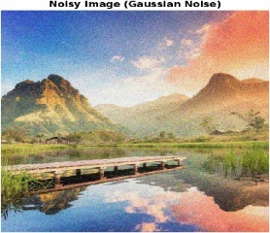
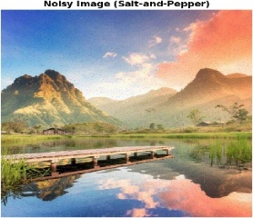
By including both these distinct noises, we can successfully analyze the model’s efficiency in denoising images.
Figure 1. Gaussian vs. Salt and Pepper Noise [1]

Neural Network Fundamentals
The Denoising Autoencoder is a specific subset of the broad Neural Network forward and backward propagation. A neural network is a machine learning model consisting of different layers of neurons, that are connected from the input layer to the desired output layer. When talking about image reconstruction, each singular pixel value is inputted into different neurons in the input layer. The input and output layers are separated by hidden layers in between which map out the entire neural network.
The relationship between each layer is defined by weights and biases. $Z=WX+B$. The weights determine the strength of connection between the neurons in different layers. This operation is a linear transformation of the neurons. For the neural network to learn nonlinear relationships, activation functions are used at the output of each layer. This algorithm uses Leaky ReLU for the hidden layers and Sigmoid function for the output layer to normalize the pixel values between 0 and 1.
The training process for the neural network involves a forward pass to generate a reconstructed version of the noisy image, and then a backward pass that calculates the error of the regeneration. Using gradient descent, the model calculates the loss function with respect to the weight and bias, and these parameters are then updated through each iteration. After multiple training iterations, the Mean Squared Error (MSE) is decreased.

The Fashion-MNIST Dataset
The dataset used for this study contains 70,000 28 x 28 grayscale images of the Zalando article images. More specifically, 60,000 training and 10,000 testing images. Each pixel in the image is associated with a value that indicates lightness or darkness (an integer in the range of 0 to 255). Each image is labeled as one of 10 clothing categories: 0 – T-shirt, 1 – Trouser, 2 – Pullover, 3 – Dress, 4 – Coat, 5 – Sandal, 6 – Shirt, 7 – Sneaker, 8 – Bag, 9 – Ankle boot [3]. Fashion MNIST is considered to be more complex than its counterpart of handwritten digits as it features various silhouettes and textures. To denoise these images, the model would need to understand how clothing drapes and shadows are affected by noise. For example, when looking at a section of a dress, the model should recognize that all parts of the clothing are connected without being affected by the pixels corrupted by noise. Additionally, the contrasts that naturally show up in the pixels from the intricacies of clothing is very different than the digits dataset, which typically feature the digit as a solid color and the paper as white.

Theoretical and Conceptual Study of the Algorithm
Autoencoders use neural networks to transform input data into compressed forms and reconstruct the input using the transformed data. The main goal is to minimize the difference between the original input and the output. DAE is a special kind of autoencoder that tries to removes noise from images to construct a clean version of the image. DAEs use unsupervised learning techniques as there is no target given, only the original input is what the model has to learn from. [4] This algorithm is useful when it comes to fixing noisy pictures in the real world, such as in bioinformatics or fraud detection.

The Denoising Autoencoder (DAE) Idea
The goal of this algorithm is to train a model that can recognize general features from an image even if it is a corrupted or noisy version of the input. DAEs are a step up from autoencoders as they are forced to learn the structure of the data rather than how autoencoders just copy input to output. The model’s main way of “getting better” is by ignoring noise and filling in the gaps between the missing pixels.

Architecture
The figure below will aid in visualizing the parts of the encoder that will be referred to in the following section.
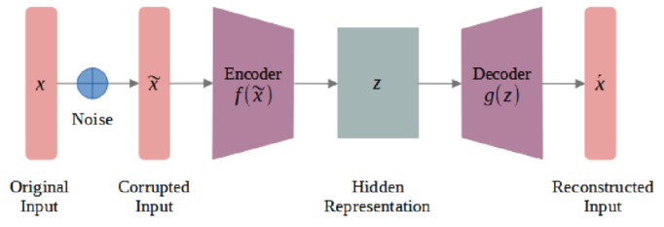
Figure 2. Architecture of a Denoising Autoencoder [2]
There are three components to a DAE which include [4]:
- The Encoder: The input to the encoder is the noisy image. Consisting of many intermediate hidden layers, this layer compresses the image by reducing the dimensions of the input and attempts to identify important features. For example, given artwork of a messy or distorted flower, the encoder must ignore the distortion and focus only on the shape of the flower. As only the important aspects of the picture are stored by compression, it is easy to send the cleaned data to the next layer.
- The Hidden Layers: After the encoder compresses the data, the hidden layers reduce the dimensions even more while also learning the features. With every pass through a hidden layer, the amount of neurons are lowered to condense the information it can receive and send as well as ignore noise. Essentially, the encoder and hidden layers work together to learn and prep the data before reaching the bottleneck. For our purposes, 3 layers consist of the encoder.
- The Bottleneck: This layer is the last layer after the encoder and before the decoder. After the data passes through the hidden layers, the bottleneck only focuses on retaining a small set of the most important features. The most compressed version of the input is created here. If there is a very small bottleneck (with only a few neurons), the data will be highly compressed but could lose more information and vice versa by holding too many non-important variables. Without the bottleneck layer, the model will just memorize all the details without actually understanding it, leading to guessing how the picture looks like rather than actually making educated decisions. In our model, the 3rd layer is the bottleneck.
- The Decoder: Given the summary of most important features from the bottleneck, the decoder builds the picture back to what it thinks the original picture is. Since the input through the encoding layers tried to ignore the noise as much as possible, the decoding layer omits those aspects while constructing the final picture. What the model has learned in the previous layers is tested here as missing parts of the image are replaced with what the model thinks should go there. Just like how the encoder to hidden layers gradually compress the input, the decoder will gradually increase the dimensions of the output to achieve the final cleaned image. For our model, the data passes through 3 layers in the decoder.
It should be noted that the encoder and decoder are trained together to help the model learn the actual structure of the data. If they were trained separately, the network might just output a copy of the input. Our DAE has a total of 6 layers.

Data Corruption
The input to a DAE is always a noisy image, of which there are many types. This algorithm compares two techniques [1]:
- Gaussian Noise: The random noise that is added to images follows a normal or Gaussian distribution. This type of noise is supposed to represent fluctuations in data so that the model does not memorize any input data. The equation is additive:
$\tilde{x}=x+ε$ (1)
Where $\tilde{x}$ is the noisy input, $x$ is the clean input data, and $ε$ is the noise vector that is sampled from a normal distribution $N(0, σ^{2})$. The standard deviation of the distribution is what determines the amount of noise that will be applied to the image. The resulting noisy pixels can be anywhere in the range of the minimum and maximum values given to each pixel in the dataset. To ensure no negative or values over 1 are introduced, the values are typically restricted stay within the range.
- Salt and Pepper Noise: The noise that is added to pixels are randomly set to black or white represented by a binary. Either the minimum or maximum value of the pixel is selected and applied as seen in the equation:
$x'\left(i,j\right)=\left\{\begin{aligned}N_{s} &probability\frac{d}{2} \\ N_{p} probability\frac{d}{2} \\ x\left(i,j\right) probability 1-d\end{aligned}\right.$ (2)
Where $x$ is the original image, $d$ is the noise density or percent of corrupted pixels (in the range of $0≤d≤1$), $x'\left(i,j\right)$ is the corrupted image at location $\left(i,j\right)$, $N_{s}$ is the salt or maximum value (255 in our case), and $N_{p}$ is the pepper or minimum value (0 in our case). The ratio of salt and pepper added to an image is usually 50/50.
The amount of noise that will be added in this implementation will be 20% for both techniques.

Math Behind the Learning
In our algorithm, the DAE model uses an iterative approach of passing data and correcting its errors. There are two main phases [6]:
- Forward Pass: The model takes a noisy input and passes it through all the layers mentioned above to create the reconstructed image. Since the data is given as a data frame, each image is processed by matrix multiplication and activation functions. For every layer, the model does a linear transformation and calculates a result $z$ following the equation:
$z=Wa_{previous}+b$ (3)
Where $W$ is the weight matrix and $b$ is the bias. Then, $z$ goes through the activation function (mentioned in section 3.E) to produce the output $a$. The process is repeated until the final layer produces $\hat{x}$ which is a guess of the clean image.
- Backward Pass: Also known as backpropagation as the model uses the chain rule to assess how each weight and bias affected the error in the reconstruction. The derivative of the Loss Function with respect to the output. In this algorithm, the Mean Squared Error function is used of which the equation is:
$MSE=\frac{1}{N}\sum_{i=1}^{N}{{\left(y_{i}-\hat{y_{i}}\right)}^{2}}$ (4)
Where $N$is the total number of steps, $y_{i}$ is the observed value, and $\hat{y_{i}}$ is the predicted value. By using the chain rule, the error calculated before is used to find a gradient for every weight and bias. The derivative of the loss equation is taken with respect to the all the individual weights and biases or more popularly, gradient descent. Updating these values is what helps the model find out what it is missing from the original image so that it can correct itself for the next iteration. The equation is:
$W_{new}=W_{old}-α\frac{δL}{δW}$ (5)
Where $W$ is the weight, $α$ is the learning rate, and $\frac{δL}{δW}$ is the derivative of the loss with respect to weight.

Activation and Optimization
Finally, the activation functions are responsible for the nonlinear transformations of the DAE algorithm. This is what primarily drives the forward pass of the neural network training pass, allowing the neural network to learn complex curves.
- Leaky ReLU [5]: This activation function is used for the hidden layers of the neural network. The standard ReLU function sets all negative values to zero, the Leaky ReLU ensures that nonzero values are 0.01.
$f\left(z\right)=max⁡(0.01z , z)$ (6)
- Sigmoid: The output layer of the decoder follows a Sigmoid activation function. The input layer pixel values are normalized between 0 and 1 by dividing each pixel value by the total (n/255). The Sigmoid activation function ensures that the output of the final layer is also between this specific range.
$f\left(x\right)=\frac{1}{1+e^{-x}}$ (7)
- Weight Update Rule: The optimization for the weights is done through the gradient descent algorithm. At the end of every iteration of the image being processed, the parameters are updated so that the Mean Squared Error is minimized. This weight update rule is essentially the Backward Pass algorithm and follows the exact same equation, as stated in Section D. Equation (5).

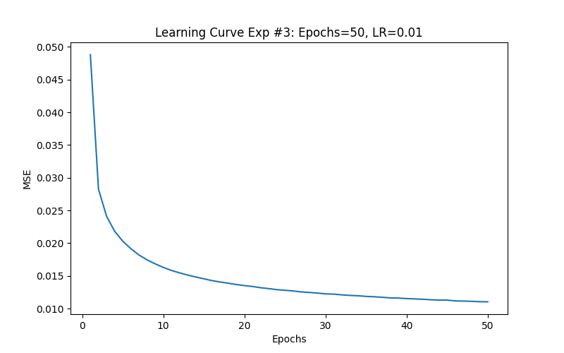
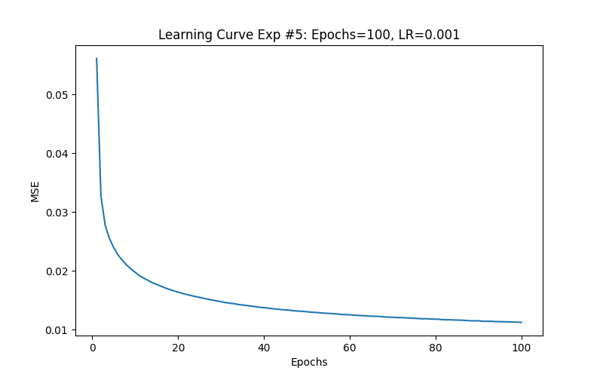
Results and Analysis
The main question to be answered is how the hyperparameters of a model affect its ability to rebuild the image as close to the original as possible. More specifically, the hyperparameters that were tested are the size of the hidden dimensions, the learning rate, and the number of epochs or amount of full passes of the training data. Additionally, how the two noise techniques, Gaussian and Salt and Pepper, effect on the final picture was observed. To keep the experiments consist, the same noise of 20% was used for both techniques. All 60,000 training instances and 10,000 testing instances were used.

Quantitative Data
The following table summarizes the total Mean Squared Error (MSE) for both the training and the testing dataset for all hyperparameter combinations.
- RESULTS
Figure 2. Learning Curve Comparison
(Gaussian, 50 and 100 epochs, Learning Rate of 0.001)
Exp # | Noise Type | Learning Rate | Epochs | Hidden Layers | Train MSE | Test MSE
1 | Gauss | 0.001 | 50 | 512,256,128 | 0.01305 | 0.0129
2 | Gauss | 0.001 | 50 | 256,128,64 | 0.01588 | 0.0155
3 | Gauss | 0.01 | 50 | 512,256,128 | 0.01104 | 0.0117
4 | Gauss | 0.01 | 50 | 256,128,64 | 0.01341 | 0.013
5 | Gauss | 0.001 | 100 | 512,256,128 | 0.01124 | 0.0112
6 | Gauss | 0.001 | 100 | 256,128,64 | 0.01374 | 0.0136
7 | Gauss | 0.01 | 100 | 512,256,128 | 0.00967 | 0.0098
8 | Gauss | 0.01 | 100 | 256,128,64 | 0.01191 | 0.0119
9 | SP | 0.001 | 50 | 512,256,128 | 0.01568 | 0.0156
10 | SP | 0.001 | 50 | 256,128,64 | 0.01826 | 0.0183
11 | SP | 0.01 | 50 | 512,256,128 | 0.01276 | 0.0132
12 | SP | 0.01 | 50 | 256,128,64 | 0.01507 | 0.015
13 | SP | 0.001 | 100 | 512,256,128 | 0.01372 | 0.0137
14 | SP | 0.001 | 100 | 256,128,64 | 0.01607 | 0.0164
15 | SP | 0.01 | 100 | 512,256,128 | 0.01158 | 0.0119
16 | SP | 0.01 | 100 | 256,128,64 | 0.01338 | 0.0134
The key output to observe here is the training error vs the test error. If the test error is very high compared to the training error, the model may be overfitting and in turn, not learning the features as much as necessary for good results. The train and test MSE of our model are extremely similar for every experiment. This shows that our model is generalized and prevents overfitting, it did not just memorize the training pattern, but it can accurately reconstruct brand new Fashion FNIST images.

Learning Rate Evalution
The image below shows the MSE vs. Epochs curve for experiment 3 and 5. Both experiments have the same hidden layer dimensions, however experiment 3 has 50 epochs and a learning rate of 0.01, while experiment 4 has 100 epochs and a learning rate of 0.001.
As seen in Fig. 3, with a higher learning rate of 0.01, the model significantly reduced the MSE just within the first 10 to 20 epochs. After the initial reduction in MSE, as the number of epochs increased, MSE started to converge. The higher epochs in experiment 5, showcased very little change in MSE. Moreover, across all the different experiments, the higher learning rate had a much lower MSE than what the 0.001 rate could achieve in 100 epochs. These results show that learning rate is the most significant hyperparameter when it comes to the efficiency of the model. The 0.01 learning rate is able to achieve better results in half the epochs of the 0.001.

Gaussian vs. Salt and Pepper
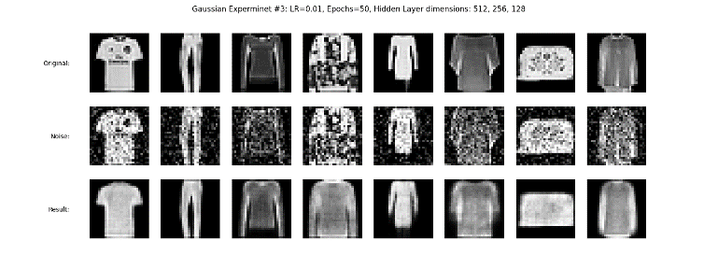
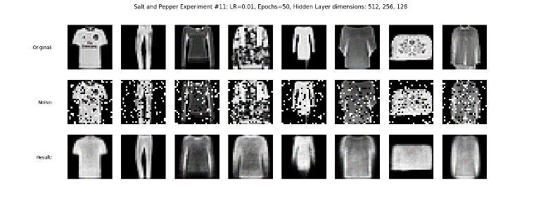
The image below compares the visual difference between Gaussian noise (Experiment #3) and Salt and Pepper noise (Experiment #11). Both experiments have the exact same hyper parameters (epochs = 50, learning rate = 0.01, hidden layer dimensions = 512, 256, 128), the only difference between these two experiments is the type of noise.
Figure 4. Visual Comparison between noise types
Fig. 4 confirms how the Gaussian noise (Top) acts like a haze throughout the entire image, while salt and pepper noise amplify 20% of the pixels to be purely black or white. Visually, the model can successfully reconstruct both types of noise, this can also be seen in the MSE since they both achieved a similar and low MSE. However, the Gaussian noise outperformed Salt and Pepper with a test MSE of 0.0117 compared to 0.0132.
Visually, the Gaussian result still has a soft haze throughout the image while the Salt and Pepper showcases sharper and clearer edges. These results show that the model was more efficient at reconstructing the normal distribution of the Gaussian noise. Meanwhile, while the Salt and Pepper results were still extremely accurate, the model was less efficient in predicting the complete dead pixels.

Hidden Dimensions
The compression size of an image as it passes through the encoder layer is worth noting as smaller hidden layers have less nodes than the input. Larger hidden layers have more nodes than the input. Both extremes can result in early bottlenecking (the model only learns a compressed version of all the features it needs to know) or high complexity (the model is more prone to overfitting and reducing quality).
In this study, the input dimension is always 784 while hidden dimensions for the 3 layers in the encoder and decoder followed 512, 256, and 128 or 256, 128, and 64. Simply put, the 28 x 28 image is flattened to become 784 neurons that are given as input to the encoder (after applying noise) and the output from the first set of neurons must be condensed by 35% if the first layer is 512 or 67% if it is 256. This continues until the bottleneck layer, which is where the number of neurons is the smallest. The decoder layer starts with the least number of neurons and unpacks as the output image reverts to 748 pixels.
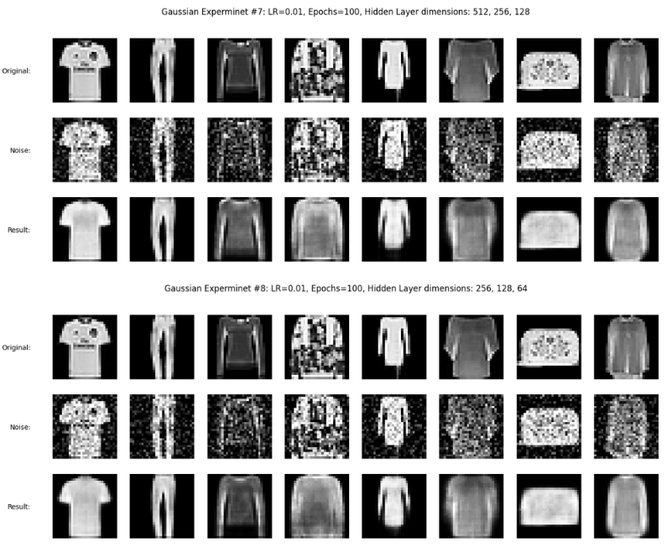
Looking at Gaussian noise, 100 epochs, and a learning rate of 0.01, results from both sets of hidden dimensions or experiments 7 and 8 are below:
Figure 5. Comparison between hidden dimensions
Both sets of dimensions were enough to preserve the shape of the clothing well, identifying that the image is a shirt or pants is not difficult. The main difference to observe is when the input image is forced to compress more of its size to 256, the reconstructed image loses some shading and details and looks to be smoother. If the DAE starts with 512 dimensions, the filter is wider to capture more textures even with the noise and the image can seem “grainer”. The same concept applies to the next set of dimensions from 512 to 256 and 256 to 128. The image is forced to condense itself and in turn, only important features are kept.
For example, the shirt in the first column has a pattern of a face. In both sets of dimensions, the face is blurred in the final image. However, when the hidden layers start at 256, the grey blur is spread from the top to the bottom of the shirt but by using 516 neurons, the gray blur is concentrated towards the top of the shirt where the face is.

Analysis
Considering all the permutations of hyperparameters and noise tested on our model, the parameters which resulted in the image that looks closest to the original consisted of 512, 256, and 128 dimensions, a learning rate of 0.01 for both types of noises. The number of epochs 50 or 100 results in very similar outputs and therefore, 50 epochs seems to be a better fit as the model can be trained faster while still learning essential details. The learning rate was picked by considering the test MSE as shown below:
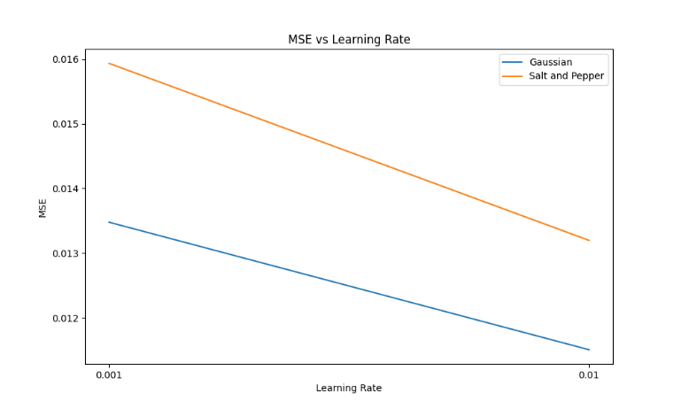
Figure 6. Test Mean Squared Error versus the Learning Rate
Regardless of the noise type used or parameters, our model makes fewer mistakes when the learning rate is 0.01. At all times, the model is trying to reach the local minimum when gradient descent applies. A learning rate is a stepping rate for the model to move back and forth while trying to converge. When 0.001 was used, the descent was very slow, and more iterations would be needed for the model to find the lowest point.
For reasons mentioned in the section above, allowing the image to compress by 35% in the first layer using 512 dimensions results in the best final constructed images compared to 256.
Finally, the model seemed to look closer to the original image with Gaussian noise as unlike Salt and Pepper where the selected noisy pixels are either white or black, the model blurred the Gaussian pixels to achieve a smoother output image. When Salt and Pepper was used, the model had to select a value for the pixel given the extremes.

conclusion and future work
This study successfully showcases the manual approach to a Denoising Autoencoder model instead of using traditional advanced Python libraries. Using NumPy to build the core functionalities of a neural network, like the forward and backward propagation, we were able to fine tune even the mathematical aspect of the model for better optimization and understanding of neural networks. The experiment results confirm that our model can successfully reconstruct noisy Fashion MNIST images and reconstruct the denoised version of the images with high accuracy.
Across all 16 experiments with various permutations of parameters, the training and testing dataset both had extremely similar MSE. This shows that our model has successfully generalized and identified the key features of the Fashion MNIST without any overfitting to the different types of noise. Experiment 3 had the lowest test MSE of 0.0117, this proves that the hyperparameters of 50 epochs, learning rate of 0.01, and dimensions of 512, 256, 128. The higher depth of the hidden layer dimensions allowed the model to visually reconstruct a clearer picture with clean edges, especially with the salt and pepper noise. We also found out that the 0.01 learning rate was significantly more efficient, as it had a lower MSE at a much faster rate. In conclusion, this manual approach of this algorithm provided us clear understanding of the weight update process and hyperparameter optimization of a Denoising Autoencoder.
Our current work mainly focused on denoising grayscale 28x28 pixel images, there are various ways to take this even further. After denoising the 28 x 28 grayscale Fashion MNIST images, we can have the model classify it between the different clothing categories and compute the minimum error of denoising that is necessary to accurately classify the images. Another way to improve the model is to train it on color images, which requires the model to work with RGB data (3 instances) instead of a grayscale value normalized between 0 and 1. This will significantly increase the number of hidden layers and the depth of each hidden layer.

References
- Z. Ansari, “Understanding Image Noise: Exploring Different Kinds of Noises in Image Processing,” Medium, Feb. 04, 2025. https://medium.com/@zar_373/understanding-image-noise-exploring-different-kinds-of-noises-in-image-processing-dcd26c6c9e5aJ. Clerk Maxwell, A Treatise on Electricity and Magnetism, 3rd ed., vol. 2. Oxford: Clarendon, 1892, pp.68–73.
- Yuliani, Asri Rizki, et al. “Robust Remaining Useful Life Prediction of Lithium-ion Battery With Convolutional Denoising Autoencoder.” Mechatronics Electrical Power and Vehicular Technology, vol. 15, no. 1, July 2024, pp. 93–104. https://doi.org/10.55981/j.mev.2024.905.
- “Fashion MNIST,” www.kaggle.com. https://www.kaggle.com/datasets/zalando-research/fashionmnist
- GeeksforGeeks, “Autoencoders in Machine Learning,” GeeksforGeeks, Jun. 21, 2019. https://www.geeksforgeeks.org/machine-learning/auto-encoders/
- “Leaky ReLU: improving traditional ReLU | MachineCurve.com,” Machinecurve.com, 2019. https://machinecurve.com/index.php/2019/10/15/leaky-relu-improving-traditional-relu (accessed May 04, 2026).
- R. Roy, “Neural Networks: Forward pass and Backpropagation | Towards Data Science,” Towards Data Science, Jun. 14, 2022. https://towardsdatascience.com/neural-networks-forward-pass-and-backpropagation-be3b75a1cfcc/

